|  |  |  |
| --- | --- | --- |
|  | **CALCULO NIVEL 2** |  |

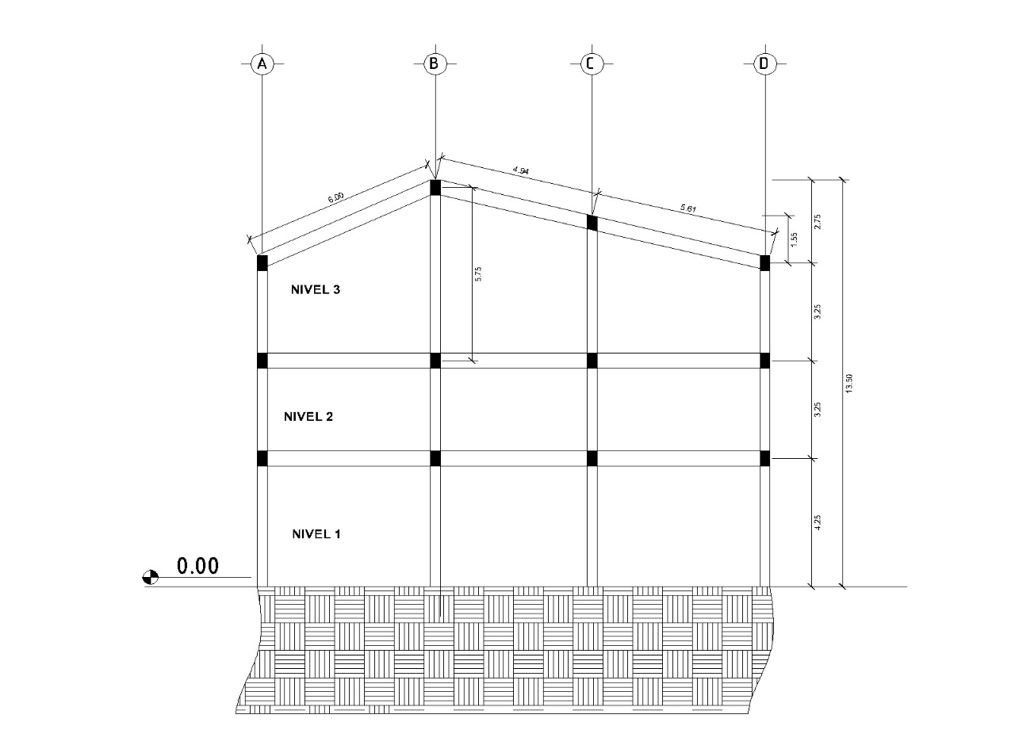

|  |  |  |
| --- | --- | --- |
|  | PESO DE COLUMNAS Y MUROS |  |

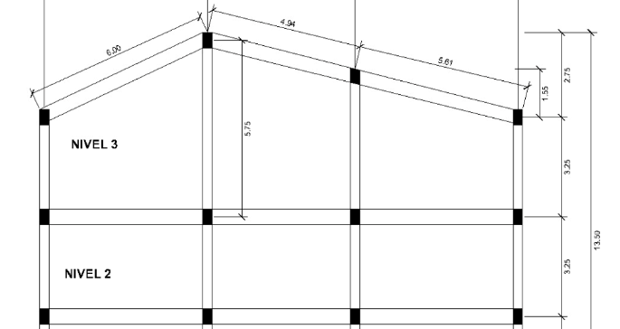

|  |  |  |  |  |  |
| --- | --- | --- | --- | --- | --- |
| **Elemento** | **Area (m^2)** | **Altura (m)** | **Peso del Concreto** | **No.** | **W** |
| **Columnas** | 0.2 | 3.25 | 2.4 | 9 | 14.04 |
| **Muro 1** | 0.45 | 3.25 | 2.4 | 6 | 21.06 |
| **muro 2** | 0.36 | 3.25 | 2.4 | 6 | 16.848 |
| **Elevadores** | 2.355 | 3.25 | 2.4 | 1 | 18.369 |
| **Peso total de Col. (Ton)** |  |  |  |  | 70.317 |

|  |  |  |
| --- | --- | --- |
|  | PESO DE VIGAS |  |

|  |  |  |  |  |  |
| --- | --- | --- | --- | --- | --- |
|  | **EJE Y** |  |  |  |  |
| **Eje** | **Base de Viga (m)** | **Altura de Viga (m)** | **Longitud (m)** | **Vol** | **Peso** |
| **A** | 0.3 | 0.5 | 3.23 | 0.4845 | 1.1628 |
| **A** | 0.3 | 0.5 | 3.73 | 0.5595 | 1.3428 |
| **A** | 0.3 | 0.5 | 3.3 | 0.495 | 1.188 |
| **B** | 0.3 | 0.5 | 4.28 | 0.642 | 1.5408 |
| **B** | 0.3 | 0.5 | 2.88 | 0.432 | 1.0368 |
| **B** | 0.3 | 0.5 | 4.28 | 0.642 | 1.5408 |
| **C** | 0.3 | 0.5 | 4.28 | 0.642 | 1.5408 |
| **C** | 0.3 | 0.5 | 2.88 | 0.432 | 1.0368 |
| **C** | 0.3 | 0.5 | 3.23 | 0.4845 | 1.1628 |
| **D** | 0.3 | 0.5 | 3.23 | 0.4845 | 1.1628 |
| **D** | 0.3 | 0.5 | 3.73 | 0.5595 | 1.3428 |

|  |  |  |  |
| --- | --- | --- | --- |
| Longitud total (m) | 39.05 | Peso total | 14.058 |
| **Area de Viga (m^2)** | 0.15 |  |  |

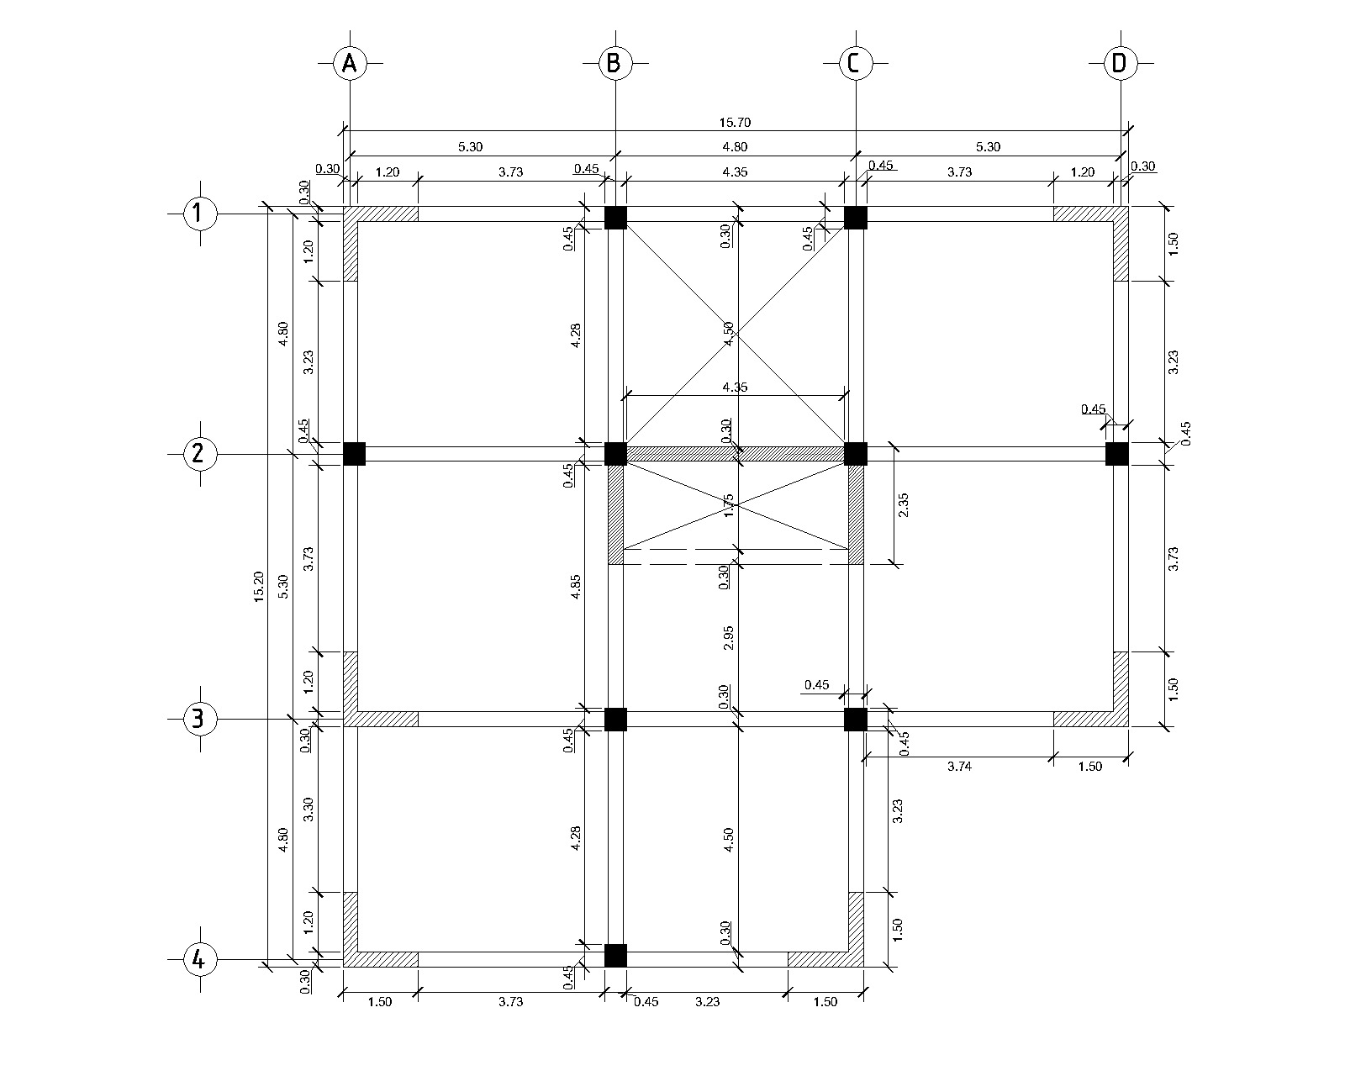

|  |  |  |  |  |  |  |
| --- | --- | --- | --- | --- | --- | --- |
|  | **EJE X** |  |  |  |  |  |
| **Eje** | **Base de Viga (m)** |  | **Altura de Viga (m)** | **Longitud (m)** | **Vol** | **Peso** |
| **1** | 0.3 |  | 0.5 | 3.73 | 0.5595 | 1.3428 |
| **1** | 0.3 |  | 0.5 | 4.35 | 0.6525 | 1.566 |
| **1** | 0.3 |  | 0.5 | 3.73 | 0.5595 | 1.3428 |
| **2** | 0.3 |  | 0.5 | 4.775 | 0.71625 | 1.719 |
| **2** | 0.3 |  | 0.5 | 4.35 | 0.6525 | 1.566 |
| **2** | 0.3 |  | 0.5 | 4.775 | 0.71625 | 1.719 |
| **3** | 0.3 |  | 0.5 | 3.73 | 0.5595 | 1.3428 |
| **3** | 0.3 |  | 0.5 | 4.35 | 0.6525 | 1.566 |
| **3** | 0.3 |  | 0.5 | 3.73 | 0.5595 | 1.3428 |
| **4** | 0.3 |  | 0.5 | 3.73 | 0.5595 | 1.3428 |
| **4** | 0.3 |  | 0.5 | 3.23 | 0.4845 | 1.1628 |
|  |  |  |  |  |  |  |

|  |  |  |  |
| --- | --- | --- | --- |
| Longitud total (m) | 44.48 | Peso total | 16.0128 |

|  |  |
| --- | --- |
| **Área de Viga (m^2)** | 0.15 |
| **Peso del Concreto** | 2.4 |

|  |  |
| --- | --- |
| Peso Total de Vigas | 30.0708 |

|  |  |
| --- | --- |
| LONGITU TOTAL Y y Z | 79.18 |

|  |  |  |
| --- | --- | --- |
|  | **PESO POR LOSA** |  |

|  |  |  |  |
| --- | --- | --- | --- |
| Losa | Longitud Y (m) | Longitud X (m) | Area ( m^2) |
| 1 | 4.5 | 5 | 22.5 |
| 2 | 4.5 | 5 | 22.5 |
| 3 | 5 | 5 | 25 |
| 4 | 2.95 | 4.5 | 13.275 |
| 5 | 5 | 5 | 25 |
| 6 | 4.5 | 5 | 22.5 |
| 7 | 4.5 | 4.5 | 20.25 |

|  |  |
| --- | --- |
| Área Total | 151.025 |

|  |  |
| --- | --- |
| Espesor de Losa (m) | 0.13 |

**PLANTA DE LOSAS**

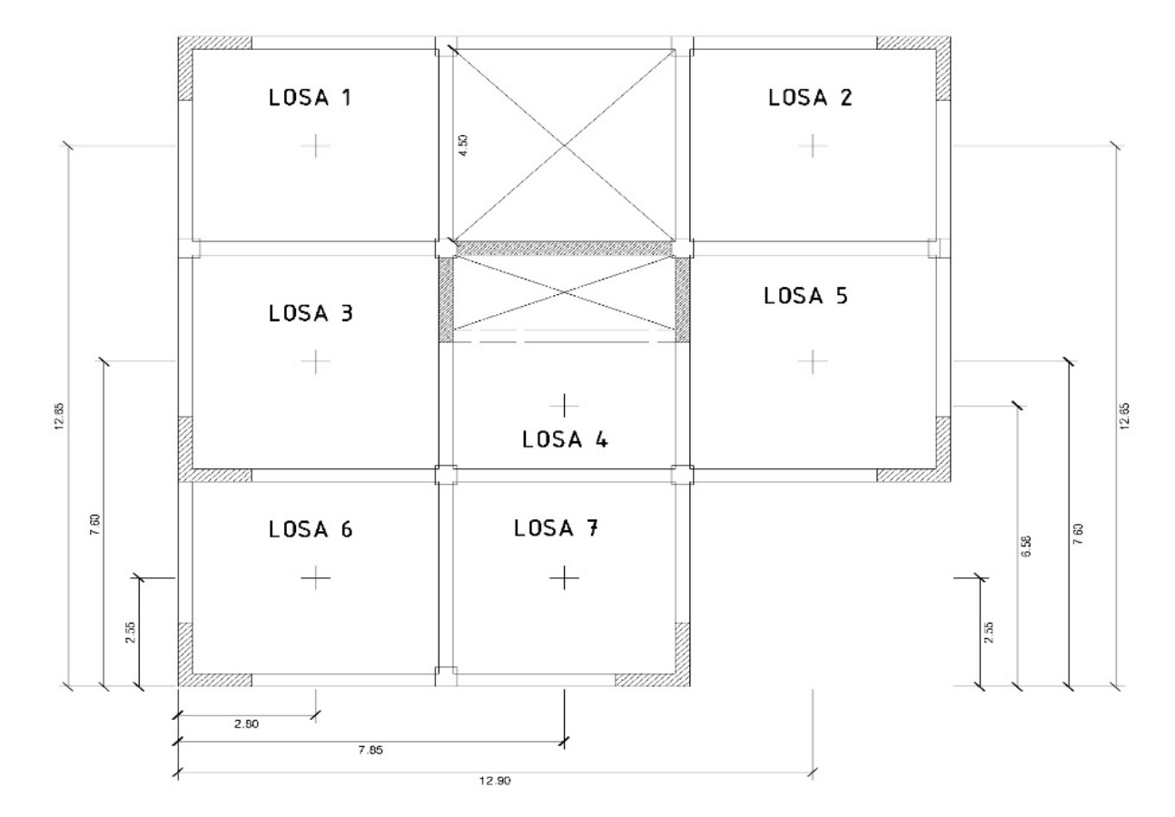

|  |  |  |  |  |
| --- | --- | --- | --- | --- |
| **Carga (kg/m2)** | **Viva** | **Sobre Losa** | **Bajo Losa** | **Sobre Carga** |
| **Techo** | 250 | 175 | 125 | 275 |
| **Carga (Ton/m^2)** | **Viva** | **Sobre Losa** | **Bajo Losa** | **Sobre Carga** |
| **Techo** | 0.25 | 1.75 | 0.125 | 0.275 |

|  |  |
| --- | --- |
| **Peso del Concreto** | 2.4 |

|  |  |
| --- | --- |
| **Wpropio (ton)** | 47.1198 |
| **WS/Losa (ton)** | 264.29375 |
| **WB/ Losa (ton)** | 18.878125 |
| **WS/C (ton)** | 41.531875 |
| **Peso de Carga Viva** | 37.75625 |
| **Peso por sismo** | 381.2626125 |
| **Carga Muerta Total** | 371.82355 |
| **Peso total de Losa** | 409.5798 |

|  |  |
| --- | --- |
| Longitud muros (m)42.21 | 79.19 |
| Altura de Muros | 3.25 |
| Wm (Ton/m^2) | 0.18 |
| W total de Muros | 46.32615 |

|  |  |  |
| --- | --- | --- |
| Peso Total por Nivel |  | 527.9765625 |